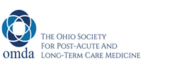  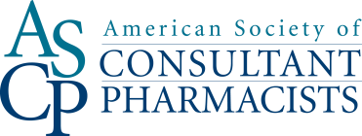  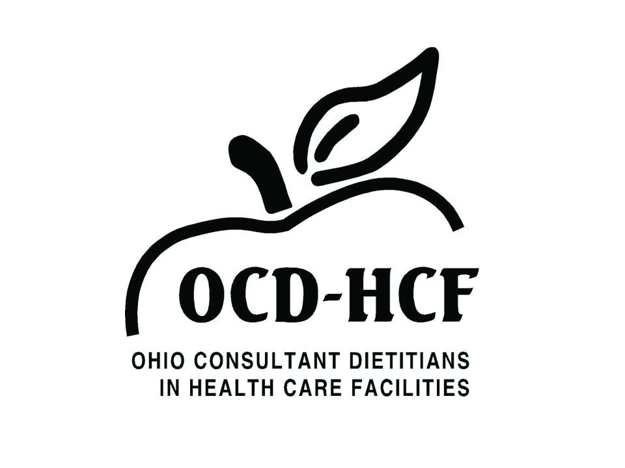

**Exhibitor Hold Harmless Agreement**

***Long-Term Care Symposium***

***Hosted by OMDA- The Ohio Society for Post-Acute and Long-Term Care Medicine***

***October 18-20, 2019***

Dear Exhibitor:

Thank you for agreeing to exhibit at the upcoming continuing medical education (CME) conference scheduled for October 18-20, 2019 at the Marriott Columbus University, Columbus, Ohio.

The exhibit fees are:

$1000:  Exhibitor table

$1250:  Exhibitor table plus Friday introduction

$2500:  Exhibitor table plus Friday introduction plus logo on meeting signage/handouts

$3500:  All the above plus product theater (does not include cost of meal)

Please make the check payable to Ohio Medical Directors Association and remit no later than September 1, 2019, to:

**OMDA**

**2465 Euclid Heights Blvd  
Cleveland Heights, OH 44106**

Set-up and tear-down times will be sent to you closer to the date of the conference. Please be advised that there are FDA restrictions on the promotion of investigational and pre-approved drugs and devices. You can obtain specific information from the FDA at this website: <http://www.accessdata.fda.gov/scripts/cdrh/cfdocs/cfcfr/CFRSearch.cfm?fr=312.7>

We are providing CME credit for the program, and therefore I bring to your attention to the following Accreditation Council for Continuing Medical Education (ACCME) Standards for Commercial Support at:

<http://www.accme.org/requirements/accreditation-requirements-cme-providers/standards-for-commercial-support>.

In connection with your participation, I ask that you sign and return a copy of this letter to acknowledge that you agree to abide by the ACCME Standards for Commercial Support, which will hold Ohio Medical Directors Association and the American Medical Directors Association harmless from any liability, damages, or costs (including reasonable attorneys' fees) that may arise as a result of your exhibiting at this CME conference. Without limiting the breadth of this hold harmless agreement, you acknowledge that it shall extend to include the loss, damage, or theft of any equipment or materials you bring to the conference site as well as injuries that any of your employees or agents may incur.

Again, thank you for your participation.

I acknowledge and agree to the hold harmless provisions set forth in this letter.

Company:______________________________

By:____________________________________

*(Signature)*

Printed Name:___________________________

Email address:__________________________

Date:__________________________________

Sincerely,

Jeannine Windbigler

Administrator

Ohio Medical Directors Association

[ohiomda@gmail.com](mailto:ohiomda@gmail.com)