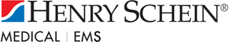 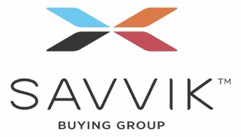 Your logo here

COVID-19 Testing Kit
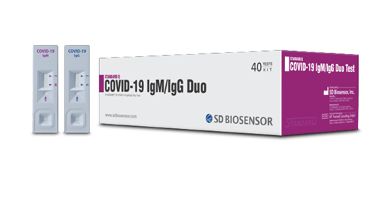
Cost is $660.00 for a box of 20
Henry Schein announced on March 26 the availability of an antibody rapid blood test, known as Standard Q COVID-19 IgM/IgG Rapid Test, intended to be administered at the point of care. The test delivers results within 15 minutes from a pinprick with no instrumentation required.
Health care professionals can use the results of the test, along with a patient’s medical history, symptoms, and results of other relevant testing, to make informed decisions about patient treatment and care. Henry Schein is working through multiple channels to distribute the tests in the U.S. as quickly as possible in response to the urgent need for rapid, accurate testing. Our initial focus will be supplying the tests to health care professionals. We anticipate having at least several hundred thousand tests available by March 30 and significantly increased availability beginning in April 2020.
Kits are not available online, please click on the button below to get registered.
COVID-19 Testing Kit Order Form

