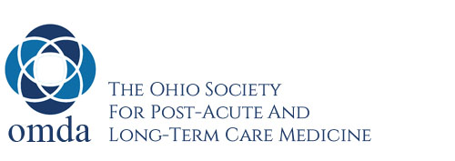
Tentative Program Schedule
5th Annual Ohio Long Term Care Symposium
OMDA Endeavors: 30 Years of Advocacy for Older Adults
Up to 12.5 CME/CEU credits available (4.5 Friday, 8 Saturday)

Friday, October 21, 2022

12:00 – 1:00 pm Registration Desk Open (Exhibit Hall open)
1:00 – 3:30 pm Hospice and Palliative Care Mini-symposium

3:30 – 4:00 pm Refreshment Break (Exhibit Hall open)
4:00 – 6:00 pm Concurrent Sessions (Clinical Track)
Focus for 2022: Orthopedics
- Management of Common Orthopedic Issues in the NH
- DVT Prophylaxis Following Reconstructive Surgery Point/Counterpoint

Concurrent Sessions (Management Track)
- Negotiating Your Medical Director Contract
- Death Certificates: Getting to the Truth

6:00 – 7:00 pm Welcome Reception (Exhibit Hall open)
7:00 – 8:00 pm Dinner (Product Theater)

Saturday, October 22, 2022
7:30 – 8:30 am OMDA Membership Meeting (Breakfast-served)
Non-members: Breakfast supplied
Exhibit Hall open

8:30 – 9:00 am General Session – AMDA Update
9:00 – 10:30 am General Session – Research Update/Fellows Forum
10:30 - 11:00 am Refreshment Break with Exhibitors

11:00 – 12:00 pm Keynote Session: Promoting and Implementing the Principles of Diversity, Equity, and Inclusion (DEI) in PALTC

12:00 - 1:00 pm Aphasia: How to Improve Communication

1:00 – 2:00 pm Lunch (Product Theater)
Exhibit Hall Open

2:00 – 3:00 pm Diabetes Management in LTC

3:00 – 4:00 pm Hyponatremia: Assessment and management

4:00 – 4:30 pm Refreshment Break
4:30 – 6:30 pm General Session – COVID-19 Panel Discussion

Adjourn General Meeting

